Task 1: In this problem statement, we will find the average fare of each class.

PIG Script



Result:

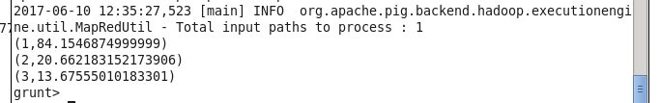

Task 2: In this problem statement, we will find the number of people alive in each class and embarked at Southampton.

PIG Script



Result:

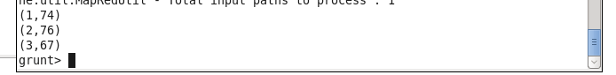

Task 3: In this problem statement, we will find out number of males and females who died in each class.



PIG Script

Result:

Male died:

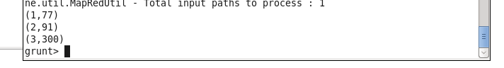

Female died:

